Classification of Defects

Substrate C-3895-23A

# Four main categories

Reddy et.al. (2014)

1. Large defects (100 – 102 um)
2. Voids (100 – 102 um)
3. Microvoids (< 101 um)
   1. Substrate-induced
   2. Process-induced
4. Morphological defects

# Elements that might be present

Cd, Zn, Te

Al, Si, Cl, S, P, Fe, Br, Cu

O, C

Smaller concentrations than 1012 atoms cm-2: Cr, Mn, Ni, Ga, Ge, As, Sr, Y, Ta, W, Pt, Au, Hg, Pb, Bi

# Observed defects

|  |  |  |  |  |
| --- | --- | --- | --- | --- |
| **Type** | **Size (μm)** | **Density (cm-2)** | **Picture** | **Comments and questions** |
| Surface scratches | Depth: < 0.0003  Width: < 0.1 |  | G:\Brukere\Oda Lauten\SEM\C-3895-23A\Detaljer\C-3895-23A_J08_detail.jpg | How much do they differ in depth and width?  What have caused the larger scratches? |
| Residual polishing grit | Length: 0.1 – 1  Height: 0.01 – 0.3 | ~5 x 106 – 2 x 108 | Al2O3    Al2O3    Al2O3    Al2O3    Al2O3 (se bildet under for bedre oppløsning / fokus)  G:\Brukere\Oda Lauten\SEM\C-3895-23A\Detaljer\C-3895-23A_tuning_09.jpg    Al2O3    Al2O3 polishing grit    Al2O3 **LIGNER IKKE PÅ DE ANDRE OBSERVERTE ALUMINA-PARTIKLENE. KAN DET VÆRE AT DET BARE LIGGER NOEN ALUMINAPARTIKLER PÅ TOPPEN AV EN CdZnTe-PARTIKKEL FOR EKSEMPEL?**    Both the agglomeration and the single particle are Al2O3    SiO2    SiO2    Mest SiO2 og litt Al2O3    Al2O3 + SiO2 + S?    Al + Si+ O    Al + Si+ O    Al + Si + O    Al + Si + O    Al + Si +O  G:\Brukere\Oda Lauten\SEM\C-3895-23A\Detaljer\C-3895-23A_tuning_03.jpg  G:\Brukere\Oda Lauten\SEM\C-3895-23A\Detaljer\C-3895-23A_tuning_07.jpg  G:\Brukere\Oda Lauten\SEM\C-3895-23A\Detaljer\C-3895-23A_J04_detail.jpg | SiO2 Al2O3 (SiC)  Both silica and alumina. Or is it silisium carbide? Is it possible to see the difference? Do they stick to each other?  Agglomerations. Does it happen in specific places or random? How many stick together? What make them stick together? Are they bound to the surface?  The observed Al2O3 polishing grit is between 50 nm and 100 nm. |
| CdZnTe particulates | Diameter: ~2 -3 | 2.8 x 103 cm-3 for diameter >10 μm | G:\Brukere\Oda Lauten\SEM\SEM til EDX\C-3895-23A_edx1_m006.jpg  Cd(Zn)Te particle    Cd(Zn)Te  G:\Brukere\Oda Lauten\SEM\SEM til EDX\C-3895-23A_edx1_m008.jpg  Cd(Zn)Te particle | Te CdTe Cd0.96Zn0.04Te  Hard to tell if they are Te, CdTe or CdZnTe on the EDX spectra.  Both clean cut pieces and uneven flakes. (Are these the same or two different things?) |
| Na + Cl particles? |  |  | Na + Cl    Na + Cl    Na + Cl    Overview of the three above    Na + Cl |  |
| Carbon based flakes |  |  | G:\Brukere\Oda Lauten\SEM\SEM til EDX\C-3895-23A_edx1_m011.jpg  C  G:\Brukere\Oda Lauten\SEM\C-3895-23A\Detaljer\C-3895-23A_tuning_06.jpg  C      C    C | The white particles on top of the flakes are Al2O3 polishing grit. |
| Circular stains | Diameter: 1 - 10 |  | G:\Brukere\Oda Lauten\SEM\SEM til EDX\C-3895-23A_edx1_m016.jpg  No other signal than Cd(Zn)Te | Weak signal from phosphorus (P) in the EDX-spectrum  Coplanar with the substrate surface. |
| Fe particles |  |  | Fe |  |
| Elliptic stains with “nucleus” at one of the epicentres | Length: 90  Width: 70 |  | G:\Brukere\Oda Lauten\SEM\SEM til EDX\C-3895-23A_edx1_m001.jpg Traces of P and Br.    Traces of P    Traces of Mg and S at the darkest spot.  G:\Brukere\Oda Lauten\SEM\C-3895-23A\C-3895-23A_B08_x500.jpg | Coplanar with the substrate surface except for some of the nucleus and some other residuals. Maybe the circular defect surrounding the nucleus is some sort of stain from drying of a droplet? |
| Splashes | Length: 15  Width: 10 |  | G:\Brukere\Oda Lauten\SEM\SEM til EDX\C-3895-23A_edx1_m003.jpg  G:\Brukere\Oda Lauten\SEM\C-3895-23A\Detaljer\C-3895-23A_tuning_08.jpg    Ikke noe annet signal enn Cd(Zn)Te |  |
| Voids | 1 – 100 |  | G:\Brukere\Oda Lauten\SEM\SEM til EDX\C-3895-23A_edx7_m002.jpg  Cd(Zn)Te  G:\Brukere\Oda Lauten\SEM\SEM til EDX\C-3895-23A_edx7_m004.jpg  Cd(Zn)Te  G:\Brukere\Oda Lauten\SEM\SEM til EDX\C-3895-23A_edx7_m003.jpg  Cd(Zn)Te    Cd(Zn)Te    Cd(Zn)Te More Cd?  G:\Brukere\Oda Lauten\SEM\C-3895-23A\Detaljer\C-3895-23A_tuning_04.jpg |  |
| Microvoids | < 10 |  |  |  |
| Large particles and other not typical defects | > 100 |  | G:\Brukere\Oda Lauten\SEM\C-3895-23A\Detaljer\C-3895-23A_F01_detail.jpg  G:\Brukere\Oda Lauten\SEM\SEM til EDX\C-3895-23A_edx3_m007.jpg    Si og litt O? | 120 μm fibre (F01)  750 μm fibre (H08)  300 μm scratch from upper left corner and diagonally downwards (can be seen with the naked eye) |
| Te precipitates and inclusions |  |  |  |  |
|  |  |  |  |  |
| Unknown |  |  | G:\Brukere\Oda Lauten\SEM\C-3895-23A\Detaljer\C-3895-23A_J11_detail_02.jpg |  |

Sjekk ut prikker på B11

Svart flekk på D01, D02 og D03 og E01

Alumina partikler E04 og E06

Krystallinsk struktur E08

Prikkete hvit flekk E09

Splasher i E11

Bølge i F03

Hva er det svarte i F10?

Hvit og svart ting i H11

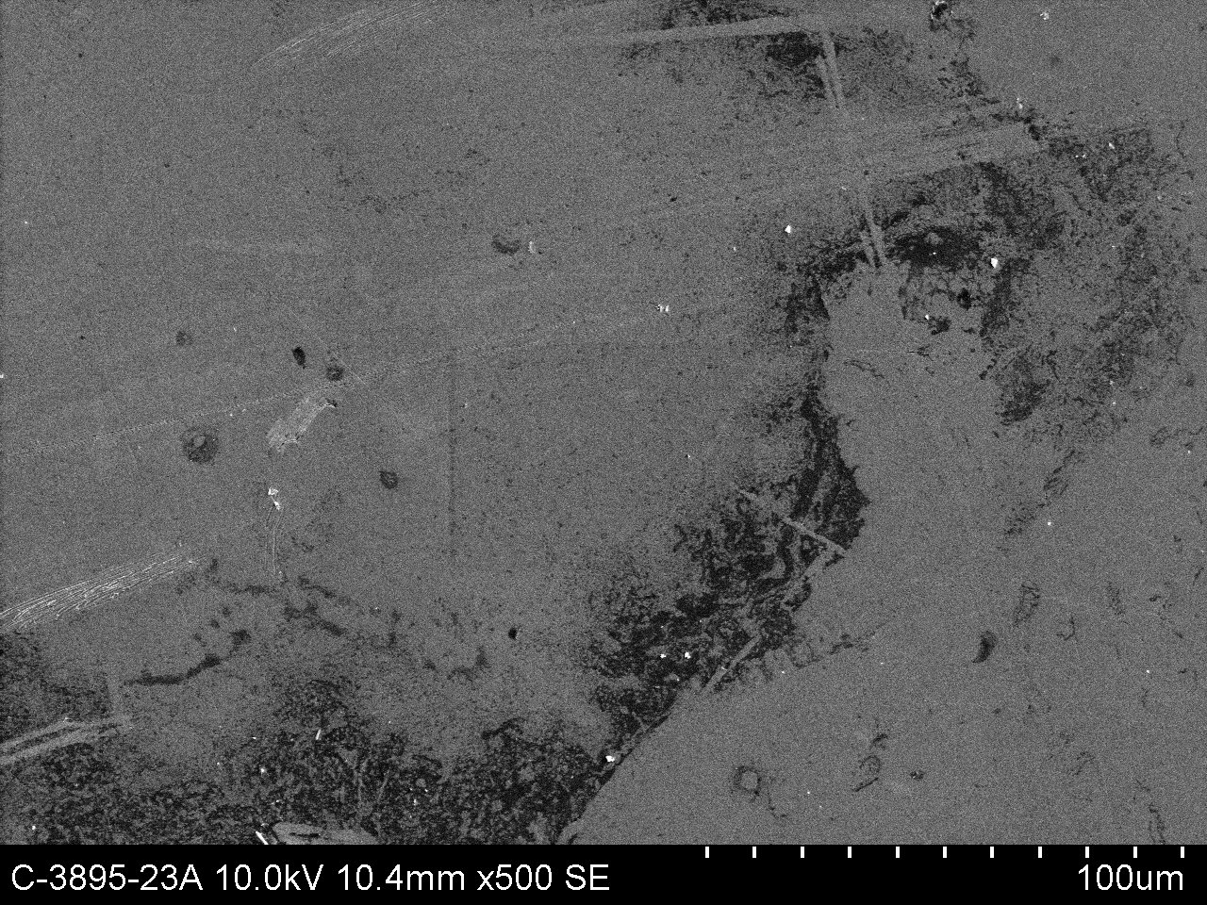

Fjellkjede J01

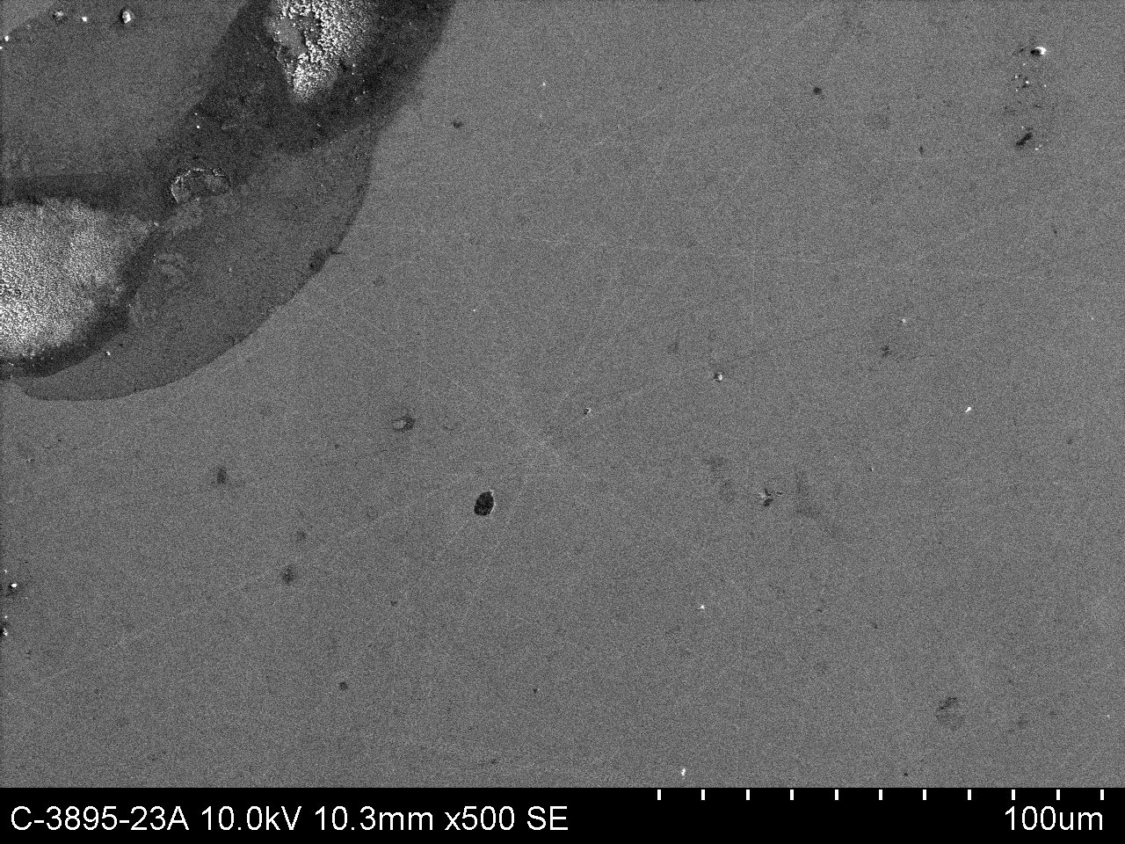

Avlang hvit flekk J04. Får ikke noe særlig signal. Kanskje Cl?

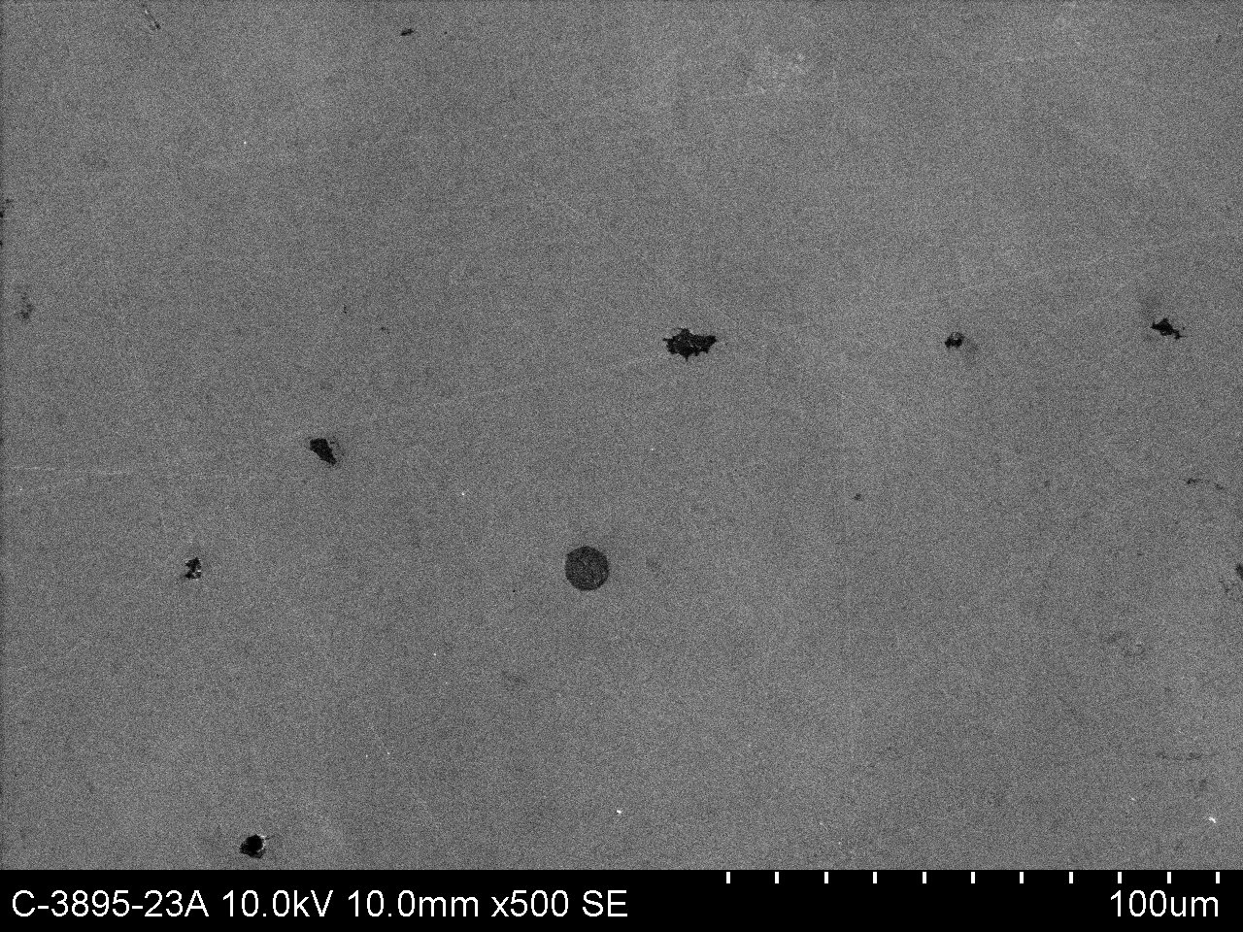

Splash og svart flekk i K09. Får ikke nok signal..

# Methods of characterization

* Scanning Electron Microscopy (SEM) med Energy-Dispersive X-ray spectrocopy (EDX)
* X-Ray Photoelectron Spectroscopy (XPS)
* Atomic Force Microscopy (AFM)
* Near IR